Alexa Voice Integration Initial Set-Up

Resources:

Register a Product

This tutorial teaches you how to register an Alexa Voice Service (AVS) Built-in device with the Amazon developer portal. You complete the following activities in this tutorial:

1. Create an Amazon developer account.
2. Register an AVS built-in device.
3. Set up your security profile.

When finished, you download the required security credentials to connect your device to AVS.

Optionally, continue with step two of the tutorial to [set up the AVS Device SDK on a Raspberry Pi](https://developer.amazon.com/en-US/docs/alexa/alexa-voice-service/required-hardware.html). This tutorial uses a handful of scripts to download, build, and run the SDK with wake word detection enabled. When finished, you have a working sample app to test interactions with Alexa.

Create an Amazon developer account

Create a free developer account at [developer.amazon.com](https://developer.amazon.com/login.html). If you already have an account, you can skip this step.

Create a product

After you've created an Amazon developer account, you create a product and security profile. This authenticates your software client so it can connect to AVS.

**To create a product**

1. Log in to the [AVS dashboard](https://developer.amazon.com/avs/home.html#/avs/home).

If this is your first time registering a product, you see a welcome screen. Click **GET STARTED**.

1. Click **PRODUCTS**.
2. Click **ADD NEW PRODUCT**.

Fill in product information

You now must fill in your product information. This information identifies your device with AVS.

**Note:** These instructions are for developers prototyping on a Raspberry Pi. If you are registering a commercial product, use your own custom information here.

**To fill in your product information**

1. Choose a **Product Name**. For example, **AVS Tutorials Project**.
2. Choose a **Product ID**. For example, **PrototypePi**. Don't use any spaces in your product name.
3. In the **Please Select Your Product Type** dropdown, select **Device with Alexa built-in**.
4. For **Will your device use a companion app?**, choose **No**.
5. In the **Product Category** dropdown, select **Other (please specify)**.
6. Write a meaningful description in the **Brief product description** box. For example, **Prototype**.
7. Under **How will users interact with your product?**, select **Hands-free**.
8. Skip the **Upload an image** step. This isn't required for prototyping.
9. Under **Do you intend to distribute this product commercially?**, select **No**.
10. Under **Will your device be used for Alexa for Business?**, select **No**.
11. Under **Is this device associated with one or more AWS IoT Core Accounts?**, select **No**.
12. Under **Is this a children’s product or is it otherwise directed to children younger than 13 years old?**, Select **No**.
13. Click **NEXT**.

Set up your AVS security profile

A login with Amazon (LWA) security profile associates your security credentials with your product.

**To set up your security profile**

1. Click **CREATE NEW PROFILE**.
2. Under **Security Profile Name**, enter a relevant name. For example, **AVS Tutorials Project**.
3. Under **Security Profile Description**, enter a relevant description. For example, **AVS Tutorials**
4. Click **NEXT**. Your **Security Profile ID** generates.
5. Select the **Other devices and platforms** tab.
6. Under **Client ID name**, enter a relevant name. For example, **Prototype**.
7. Click **Generate ID**.
8. Click **Download**. This downloads your **config.json** file that contains your AVS credentials. Save the file to your /home/pi directory. If you are creating this profile from a different PC, you must transfer it to your Raspberry Pi.
9. Read the Amazon terms and conditions. If you agree, check the **I agree to the AVS agreement and the AVS Program Requirements** box.
10. Click **FINISH**. Congratulations! You now have access to AVS.
11. A pop-up appears. Click **OK**. You can now view your device on your [AVS dashboard](https://developer.amazon.com/avs/home.html#/avs/homes).

The following screenshots highlight the important steps described in the previous section.

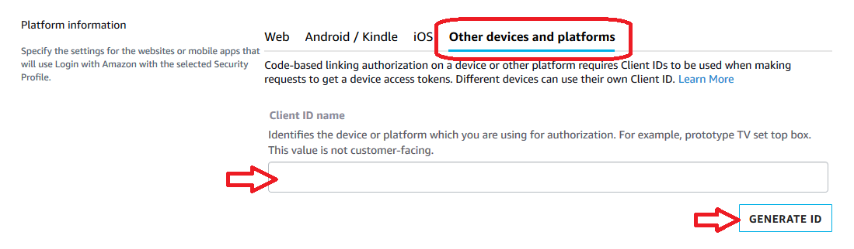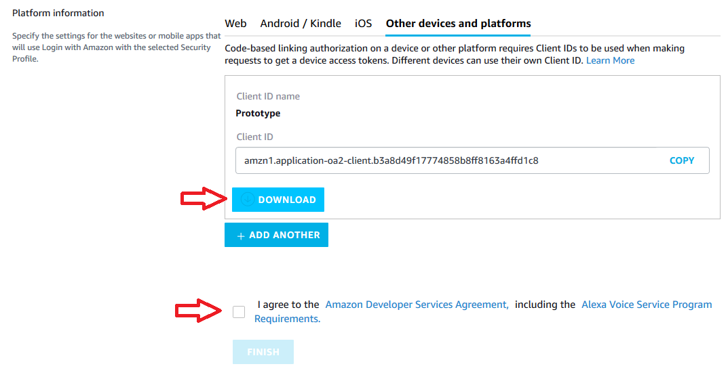

Optional: Enable your security profile for commercial distribution

**Note:** Skip this step if you are creating a prototype or testing the service.

If you're building a commercial product, you must provide your customer a link to your privacy policy.

1. Open a web browser, and visit <https://developer.amazon.com/lwa/sp/overview.html>.
2. Near the top of the page, select the commercial device security profile you created earlier from the drop-down menu and click the **CONFIRM** button.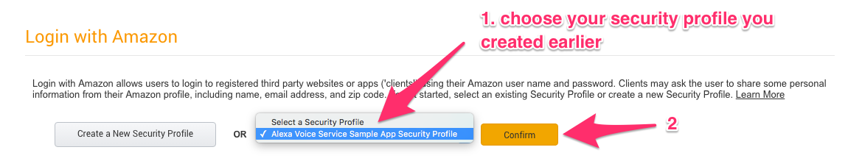
3. Enter your privacy policy URL beginning with http:// or https://.
4. *Optional*. Upload an image. It displays on the Login with Amazon consent page.
5. Click **SAVE**.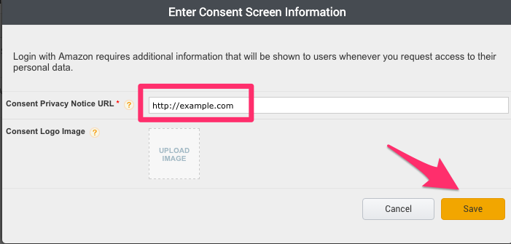

Now that you've created your product profile, it's time to get your hardware and start building.